Milestone 6: Generate Reports
Project: Enterprise AI Face Recognition Attendance System
Author: Pritish Ghosh

1. Objective
Automate attendance marking, generate daily/weekly reports, and develop dashboards for attendance trend visualization.

2. Dashboard Overview
The main dashboard (/dashboard) displays four key metrics:
Metric | Description | Visual
Total Users | Number of registered members | StatsCard with trend indicator
Present Today | Users marked present | StatsCard with percentage
Late Arrivals | Users who checked in late | StatsCard with trend
Absent Today | Users not checked in | StatsCard with percentage

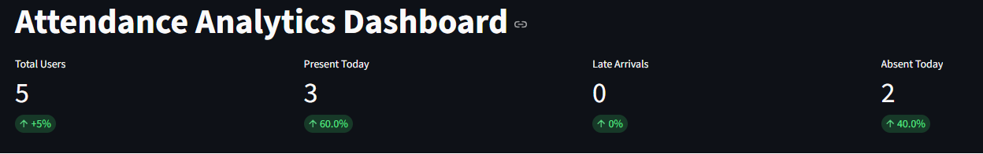

3. Analytics Charts

3.1 Monthly Attendance Rate (Line Chart)
Displays attendance rate trends over 6 months using Recharts LineChart. Shows percentage values (80-100%) with interactive tooltips.
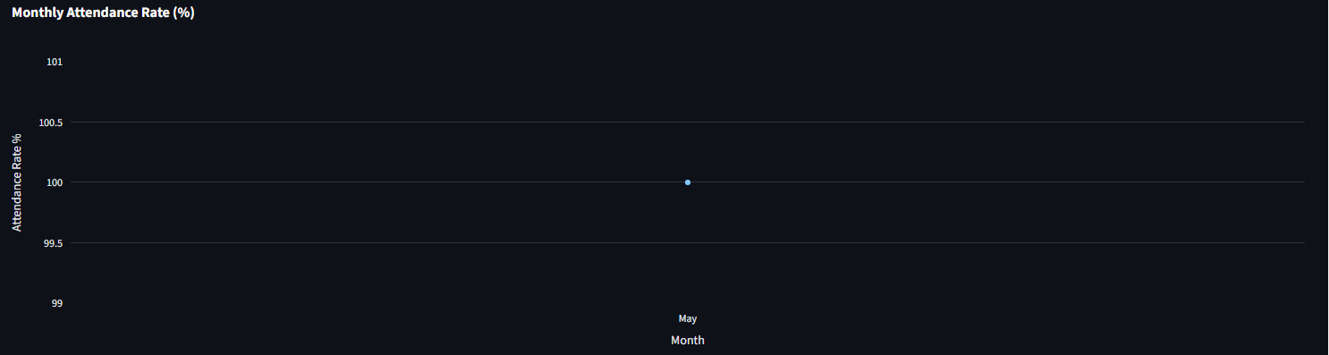

3.2 Attendance Distribution (Pie Chart)
Donut chart showing the breakdown of Present, Late, and Absent records with color-coded segments and legend.
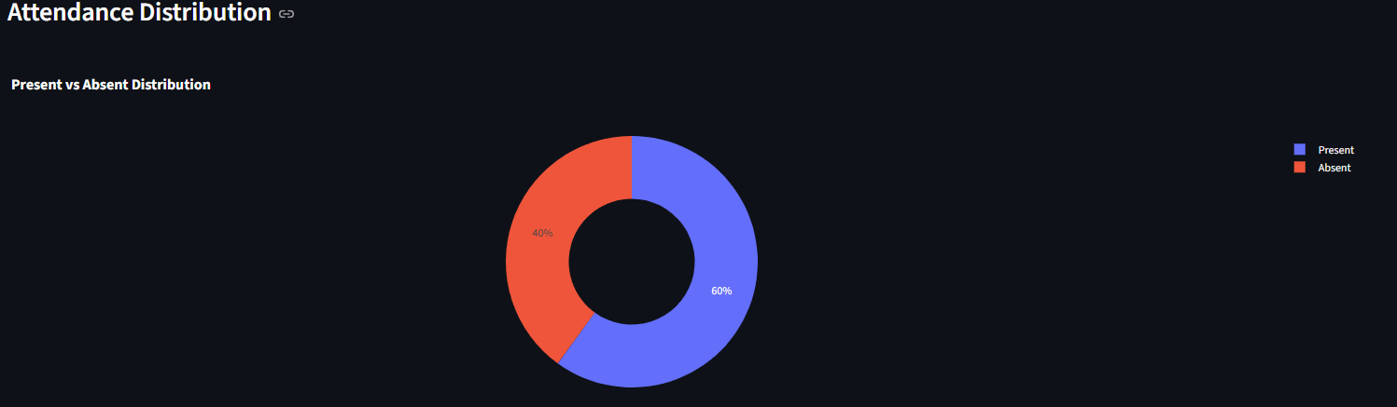

3.3 Weekly Attendance Rate (Bar Chart)
Full-width bar chart comparing weekly attendance rates (W1-W4) with rounded bars and grid lines.
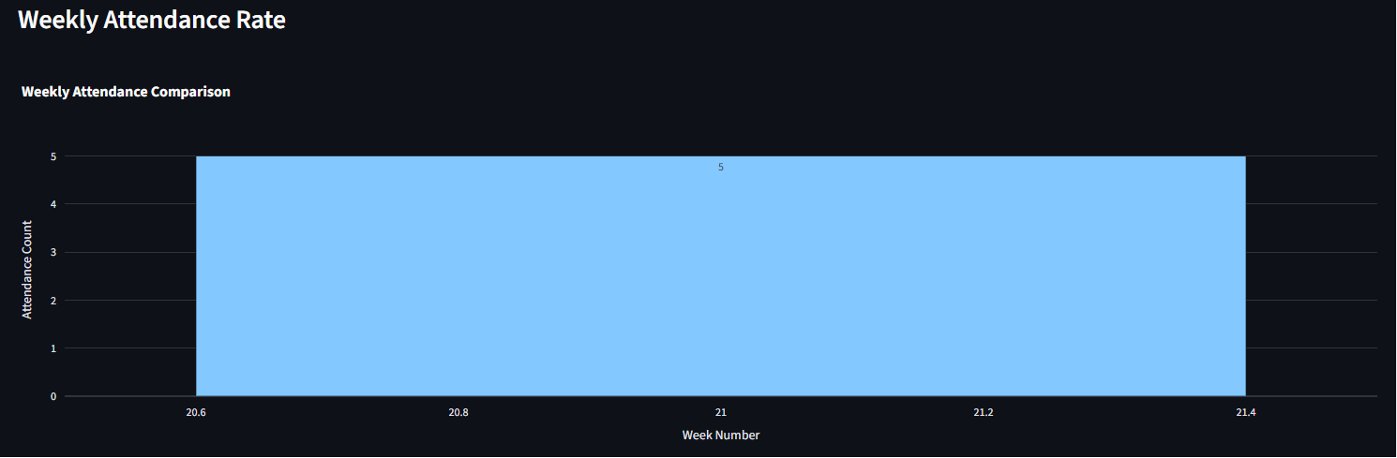

3.4 Daily Attendance Trend (Area Chart)
7-day attendance count trend displayed on the dashboard with gradient fill area chart.
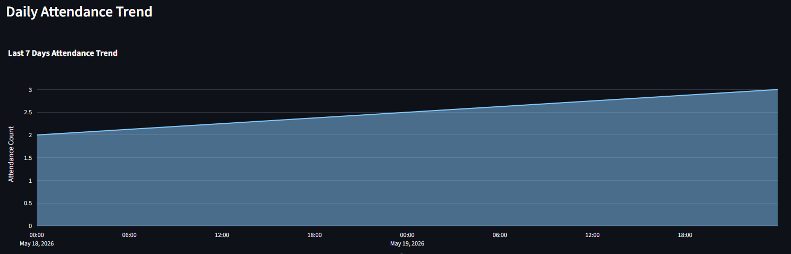

4. Attendance History Table
The /attendance page shows a detailed table with:
- Date (formatted as MMM dd, yyyy)
- Status badge (color-coded: present/late/absent)
- Check-in and check-out timestamps
- Method indicator (facial recognition icon or manual)
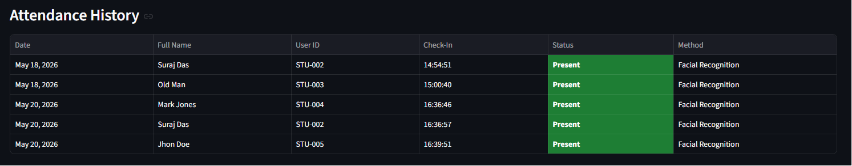

5. Report Features
- Real-time data from PostgreSQL attendance_logs table
- Responsive charts that adapt to screen size
- Dark-themed glassmorphism UI consistent with system design
- Animated chart transitions using Framer Motion
- JetBrains Mono typography for data labels

6. User Management
The /users page provides admin visibility into all registered users with columns for name, email, department, and join date.

7. Technology Stack for Reports
Component | Technology
Charts | Recharts (React charting library)
Animations | Framer Motion
Date Formatting | date-fns
Styling | Tailwind CSS v4 with oklch color tokens
Data Source | Supabase PostgreSQL with RLS

8. Conclusion
The reporting module provides comprehensive attendance analytics through interactive charts, detailed tables, and real-time data visualization, enabling administrators to identify attendance patterns and take data-driven actions.

